

Question 1 API Response Comments endpoint

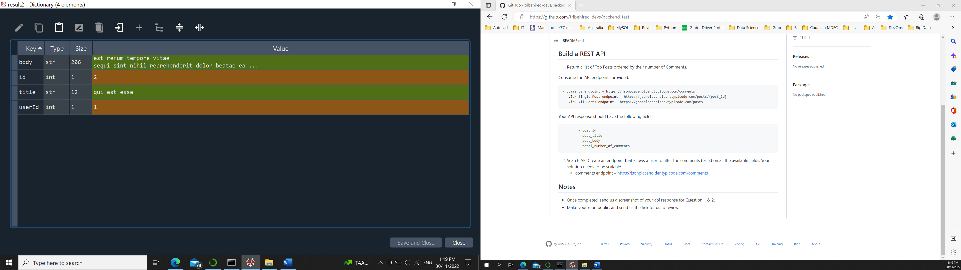

Question 1 API Response View Single Post endpoint

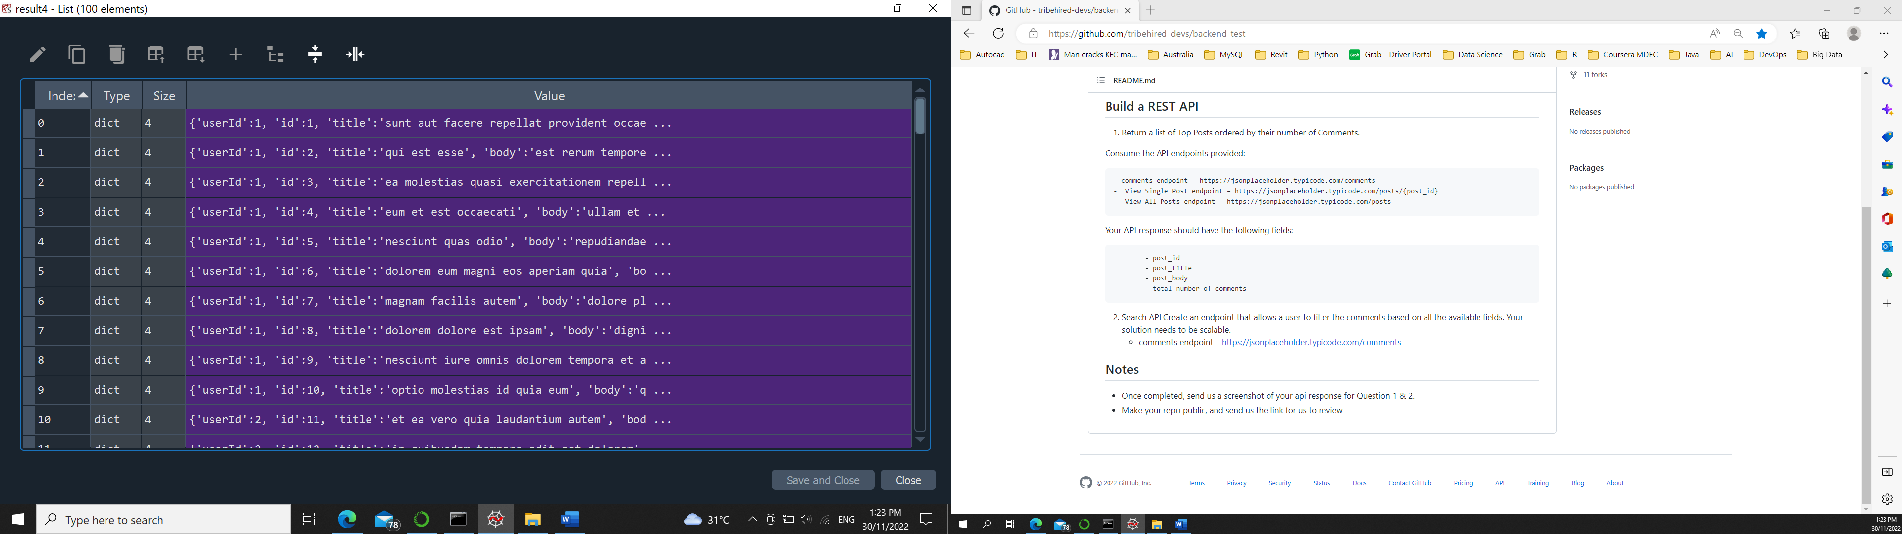

Question 1 API Response View All Posts endpoint

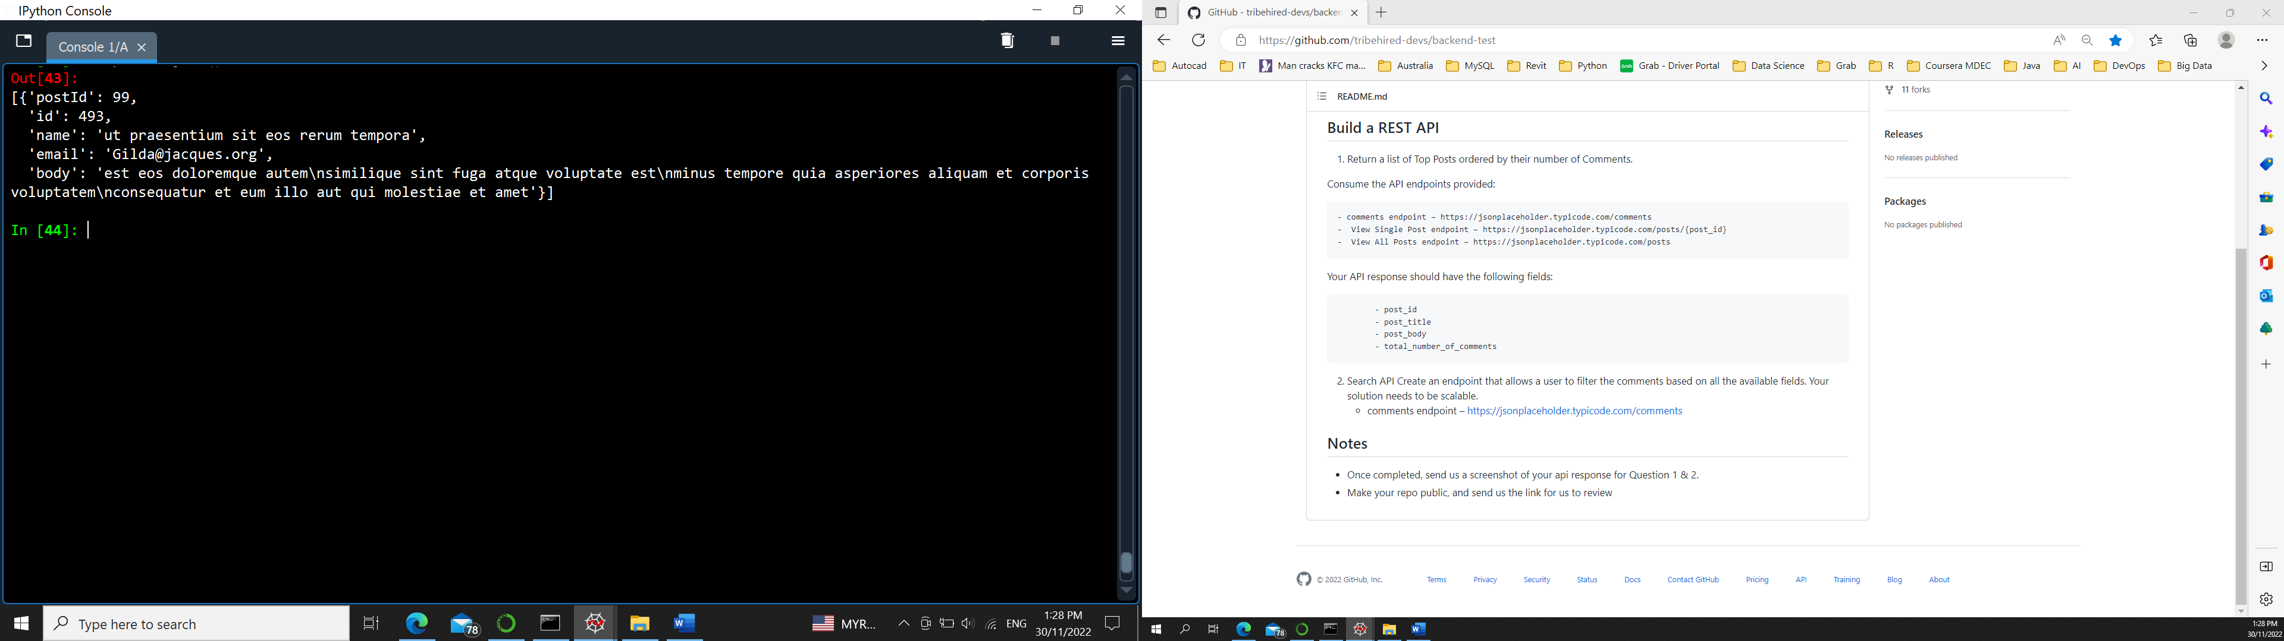

Question 2 API Response Search and filter for two resources

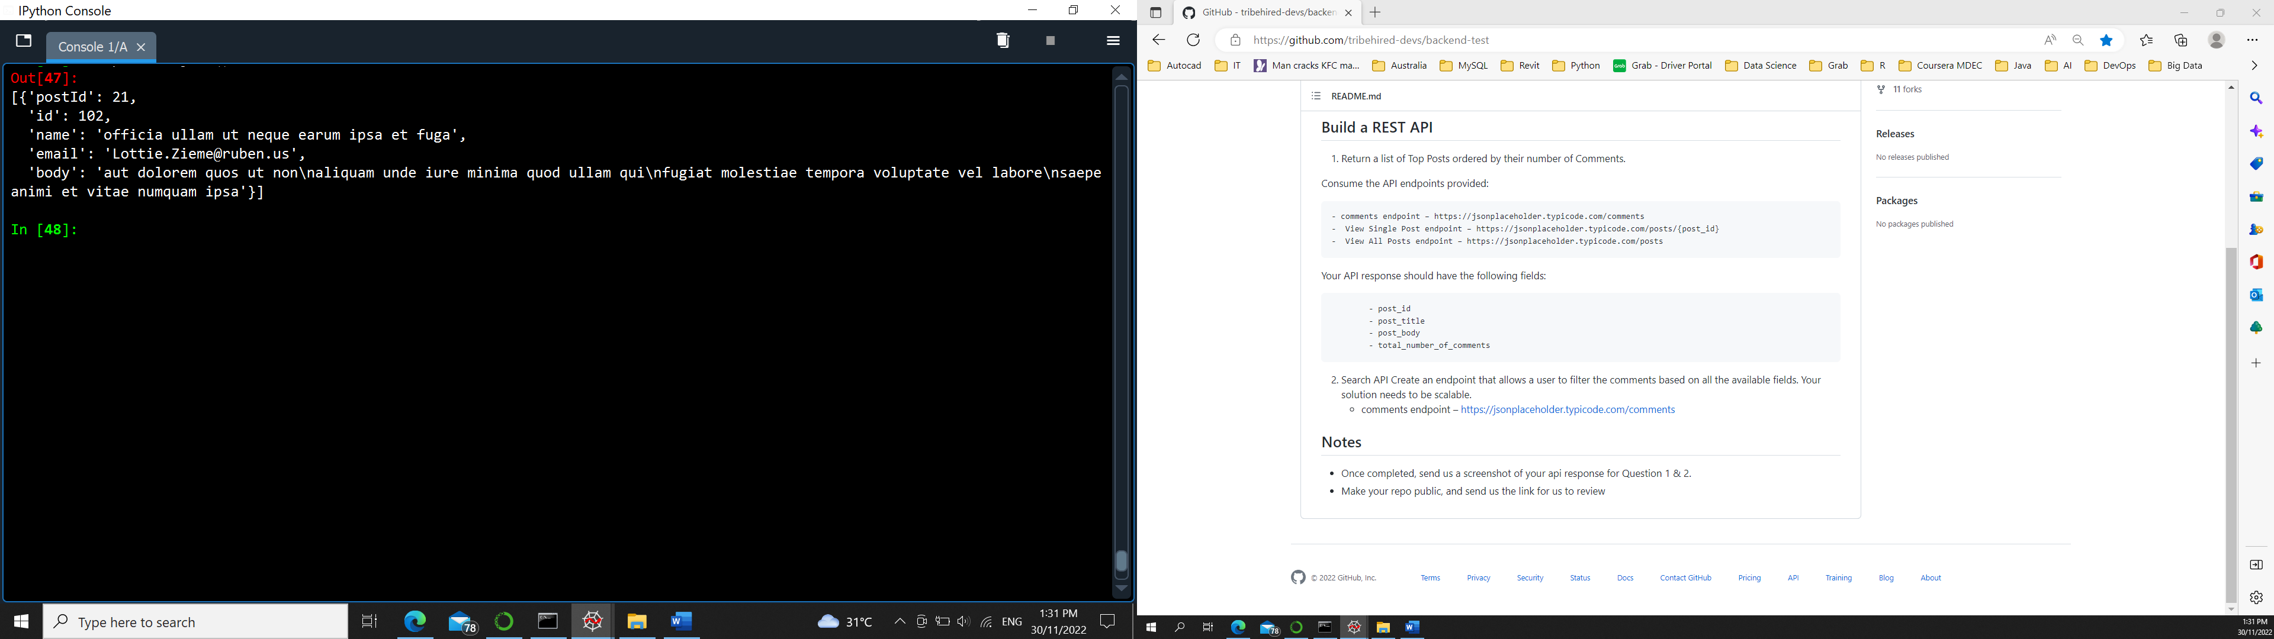

Question 2 API Response Search and filter scalable to three resources